AGFORWEB
Methodology for digital database

Project information
Project title | Agroforestry practices in West Balkan for sustainable development: weaknesses and strengthsrefere
Project acronym | AGFORWEB
Project reference number | 2022-1-RS01-KA220-HED-000089900
Coordinator | University of Belgrade
Project start date | December 1, 2022
Project duration | 24 months

Document control sheet
Title of the Work Package | WP2 Preparation
Title of Deliverable | Methodology for digital data base
Institution(s) and Author/s of the deliverable | University of Belgrade  Aleksandar Baumgertel and Predrag Miljković
Contact | Aleksandar Baumgertel  aleksandar.baumgertel@sfb.bg.ac.rs
Status of the document | Draft

Contents
1. INTRODUCTION 4
2. METHOD 4
3. ATTRIBUTE TABLE 5
4. Preliminary identification of Agroforestry practices 10
4.1. Identification on AF practices based on high-resolution images 10
CONCLUSION 14

1. INTRODUCTION

This guide contains the methodology for identifying agroforestry practices, collecting and storing the data into spatial database in form of shapefile with accompanying attribute table that carry additional specific information on agroforestry practices. The database will include the most common agroforestry practices in countries of AGFORWEB consortium as following:
- Protective forest belts
- Alley cropping
- Silvopastoral systems
- Forest farming
A combination of office work (analyzing high-resolution images to identify potential locations of agroforestry practices, digitalization of existing non-digital databases, or storing of available information on existing agroforestry practices in different formats into digital database, storing the data obtained in field into digital database (detailed explained in chapter 3 – Attribute table) and field work that is planned to collect the information on agroforestry practices in format ready to be stored into attribute tables.

2. METHOD

The data collection process largely depends on whether there are existing databases on agroforestry practices or not.
- In case there are existing databases on agroforestry practices

c. Creating a shapefile and filling in the attribute table

b. Collection of information of AF practices for the purposes of creating an attribute table

a. Databases on existing AF practices
Based on information (on location) from an existing database (a), it is necessary to perform fieldwork and collect (or update) the required information in the attribute table (b), and finally create shapefiles and fulfill the attribute table.
- If the existing database does not exist

d. Creating a shapefile and filling in the attribute table

c. Collection of information by AF practices for the purposes of creating an attribute table

b. Databases on existing AF practices

a. Preliminary identification of AF practices

In case there is no an existing AF database, the first step, Preliminary identification of AF practices has been added. The preliminary identification process depends on the type of practice and the available information about the practices. For example, locations of agroforestry practices can be obtained from the municipality, statistical yearbooks, forest enterprises etc. On the other hand, it is possible to contact associations that can provide information on agroforestry locations (e.g., Organic food production associations). In the Republic of Serbia, Preliminary identification of AF practices involves usage of high-resolution orthophoto images (explained in detail in chapter 4).

3. ATTRIBUTE TABLE

When filling out the GIS attribute table/database (excel table attached, with an example), it is necessary to enter data for those parameters related to agroforestry practices. For linear type of AF systems (shelterbelts/windbreaks and alley cropping), the attribute table is part of line/polyline shapefile. For non-linear AF systems (silvopastoral system, forest farming), the attribute table is part of polygon shapefile.
The attribute table contains the parameters listed below, where the markings are O – data must be entered for all AF systems, L – data must be entered for linear type of AF systems, P – data must be entered for non-linear type of AF systems, N – data not required to be entered, but desirable.
- Country code (O)
- Municipality (O)
- Type of AF system (O)
- Entry number (O)
- Type of agriculture (L, P)
- AC Crops (N)
- AC Animal husbandry (P)
- FC Trees and shrub species (L, P)
- FC Density (number of trees per ha) (P)
- FC Length (m) (L)
- FC Width (m) (L)
- FC Number of rows (L)
- FC Linear plantings area (ha) (L)
- FC Distance of trees in a row (m) (L)
- FC Distance between rows (m) (L)
- FC Representation of different species (L, P)
- FC Horizontal composition (L, P)
- Potential natural vegetation type (O)
- Geology (O)
- Soil type (O)
- Average annual T (Celsius degree) (O)
- Average annual P (mm) (O)
- Remarks (N)
- Photo (O)
- Date inserted (O)

- Country code – represents international alpha-3 code (Serbia – SRB; Croatia – HRV; Bulgaria – BGR; Montenegro – MNE).

- Municipality – the municipality where AF system is being recorded.

- Type of AF practice – represents the agroforestry practice. In the table, to be entered the abbreviation of AF practice, given in the brackets below.
- Alley cropping (A)
- Forest farming (F)
- Shelterbelts/Windbreaks (W)
- Silvopasture (S)

- Entry number – represents the unique number assigned to the entry of an object.
- For shelterbelts/windbreaks, forest farming and silvopasture, the numbers will be from 1 to n.
- For alley cropping, the numbers will be from 1.1 to n.n, which means that one alley cropping system will have as many entries as there are rows of the forest component, ie. from 1.1 to 1.n (eg. Alley cropping 1.3 means that first alley cropping system and third row of forest component for that system is being recorded).

- Type of agriculture – represents the type of agricultural practice and it can be arable farming, vegetable farming, animal husbandry, combined...

- AC Crops – List crops (corn, wheat, soybeans, other legumes...)

- AC Animal husbandry – represents the type of animal husbandry (cows, sheep, pigs, bees, etc.).

- FC Trees and shrub species – a list of shrub and woody species represented in the forest component of agroforestry systems. In the table, it is necessary to state the full Latin name including the author (eg. Betula pendula Roth). The accepted Latin name of the species can be checked on the World Flora Online website (http://www.worldfloraonline.org/). Check the status for information on name accepted.

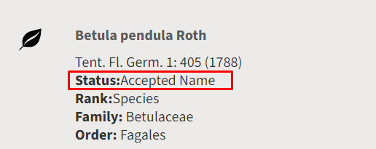 Fig 1. Status of the species name

In addition to the Latin names that should be entered in the table, it is also necessary to submit .docx file with unique list of species with Latin and domestic names. This material will be used when writing a publication, which represents one of the results/outputs of the project (textbook for students).

- FC Density (number of trees per ha) – represents the number of trees per unit area (ha). And it refers to non-linear agroforestry systems.

- FC Length (m) – In linear agroforestry systems, it represents the length (m) of the forest component.

- FC Width (m) – In linear agroforestry systems, it represents the width (m) of the forest component. The width represents the distance between the tree of the first and the tree of the last row + additional 2 m (1 m on each side, from the trees of outer row towards the open space,).

*If different for alley cropping, colleague VLADIMIR IVEZIĆ will correct this calculation.

- FC Number of rows – In linear agroforestry systems, it represents the number of rows of shrub or woody component.

- FC Linear plantings area (ha) – represents the area of the forest component in linear agroforestry systems.

- FC Distance between trees in a row (m) – represents the distance between two seedlings or mature tree of a shrubby or woody component in a row.

- FC Distance between rows (m) – represents the distance between two rows of shrubby or woody components in linear agroforestry systems.

- FC Representation of different species – represents the condition (representation) of woody plants and shrub species in the forest component of AF system. This parameter can be good (score 3), moderate (score 2), or poor (score 1) (Podhrázská et al., 2021).
Parameters of different representation of woody plants and shrub species | Score
Representation of basic and supplementary woody plants up to 30% | 1
Representation of basic and supplementary woody plants 50–31% | 2
Representation of basic and supplementary woody plants over 51% | 3

- FC Horizontal composition – represents the gaps in vegetation (dysfunctionality). Depending on the gaps percentage, it can be scored as good (score 3), moderate (score 2), or poor (score 1). (Podhrázská et al., 2021).
Parameters of the horizontal composition of woody plants and shrubs
Gaps in the vegetation (dysfunctionality) exceed 50% of space | 1
Gaps in the vegetation (dysfunctionality) up to 30% of space | 2
Gaps in the vegetation (dysfunctionality) up to 10% of space | 3

- Potential natural vegetation type
Source: EuroVegMap
Download: https://www.synbiosys.alterra.nl/eurovegmap/
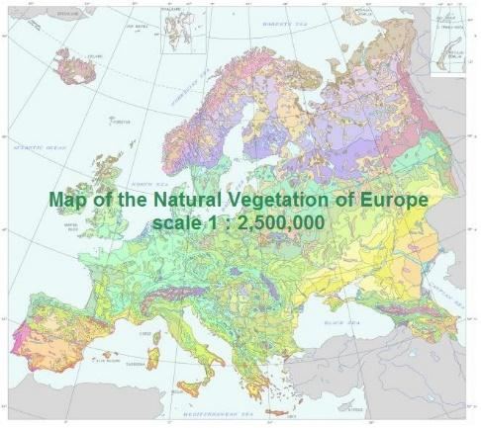  Fig 2. EuroVegMap | The map of the natural vegetation of Europe (Fig 2) provides information about the form, natural variety, and spatial distribution of the main vegetation units of the natural vegetation cover in the individual regions of Europe (natural biological diversity). In addition, it shows the location and total extent of areas with similar site qualities and environmental conditions, and thereby the comparable natural growth potential, the entire range and the geographical differentiation of a unit (e.g. the further subdivision of beech forests according to trophy and altitudinal belts, as well as into geographic and ecological forms).

EuroVegMap contains:
- map in GIS format with layers of information (vegetation zones, vegetation codes);
- explanatory text with codes for vegetation units.
- the plant species grouped alphabetically.
- general literature and maps used for vegetation mapping.
- glossary and other information.

It is possible to select the area of ​​interest to export to Google Earth or image format, with additional information layers. For the selected areas and vegetation units (Fig 3-a), software contains the explanatory text with information about the vegetation. It is also accessible in PDF format.

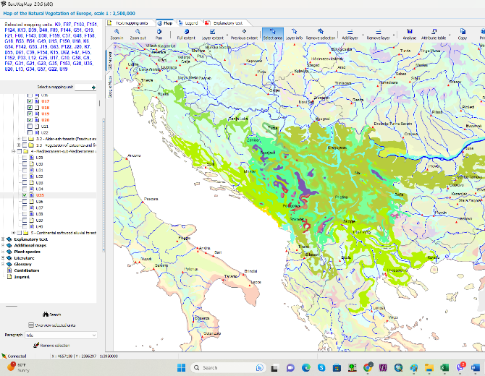 | 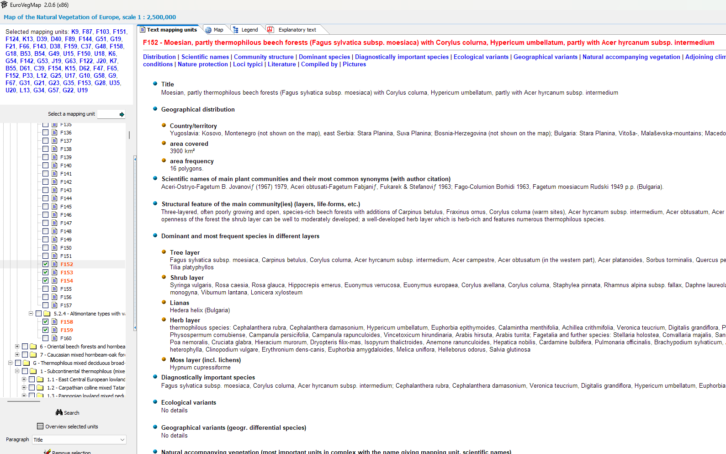
Fig 3-a. EuroVegMap - map vegetation units | Fig 3-b. Vegetation codes - II hierachiecal level

For parameter “18. Potential natural vegetation type” please provide Map unit on II hierarchical level. (Example: “F152 - Moesian, partly thermophilous beech forests”, Fig 3-b).

- Geology – From the available national, institutional, and similar databases, indicate the type of parent material of the study AF area.

- Soil type – represents the soil type of the study AF area. Data taken from available national, institutional, and similar databases, and the names of soil types must be translated to the WRB (World Reference Base for Soil Resources) classification. If available, it is desirable to specify prefix and suffix qualifier. For example. Haplic Cambisol (Eutric) – Soil type: Cambisol; prefix qualifier: Haplic; suffix qualifier: Eutric).

- Average annual T (Celsius degree)– climate parameter temeprature, in Celsius degree*

- Average annual P (mm) – climate parameter precipitation, in milimeters*

- Remarks – is a descriptive parameter, which will contain all additional significant elements of the agroforestry system. Maintenance measures, yields, proximity to protected natural reserves, whether there are protected plant species on the site, potential risks from exploitation, proximity to highways or industrial zones and landfills, etc. It all can be listed here.

The photos (numbers 23-26) represent a digital record/documentation of the existing agroforestry systems, and must be actual, from a specific location, and not from earlier archives, since the database of the actual condition of AF systems is being created. Photos to be delivered in separate. Photos must be of the following content:
- Photo 1 – For all types of AF, a photo inside the AF system (inside shelterbelt, inside alley cropping area, inside forest farming system, or in the open of silvopasture systems).

INSTRUCTIONS for adding photos:
If using ArcMap:
ArcMap only allows to add one field where you can add photo/raster in attribute table. For the shapefile to support adding the photo in the attribute table, it is necessary that the shapefile is located in the geodatabase. When a new field is added in the attribute table, for field type, the “Raster” should be selected.

If using QGIS
QGIS allows to add many fields to add the photos, but it stores it as the path where the photos are located. When a new field is added in the attribute table, for field type, the “Text” should be selected. The detailed instructions for adding the photo paths to attribute table in QGIS are given in the video:
https://www.youtube.com/watch?v=O9skgu4j7v0
The photos should be stored in folders for each entry in attribute table.

- Date inserted – Represents the date of data entry into the AGFORWEB database. It should be entered in the format yyyy.MM.dd. Eg. April 15th, 2023 will be 2023.04.15.

References:
Podhrázská, J.; Kučera, J.; Doubrava, D.; Doležal, P. Functions of Windbreaks in the Landscape Ecological Network and Methods of Their Evaluation. Forests 2021, 12, 67. https://doi.org/10.3390/f12010067

4. Preliminary identification of Agroforestry practices

This chapter proposes a methodology for the preliminary identification of forest protection belts in Serbia. However, each partner can carry out the preliminary identification in a way that is adapted to the available information on AF practices.

4.1. Identification on AF practices based on high-resolution images
Within this step, an analysis of high-resolution images (e.g. orthophoto images with a minimum resolution of 40 cm) is planned to identify the locations of linear objects (agroforestry practices) at the municipal level. For this purpose, in Serbia, a database provided by the "National Spatial Data Infrastructure" - "GEO SERBIA" - https://geosrbija.rs/en/ (Figure 1) was used.
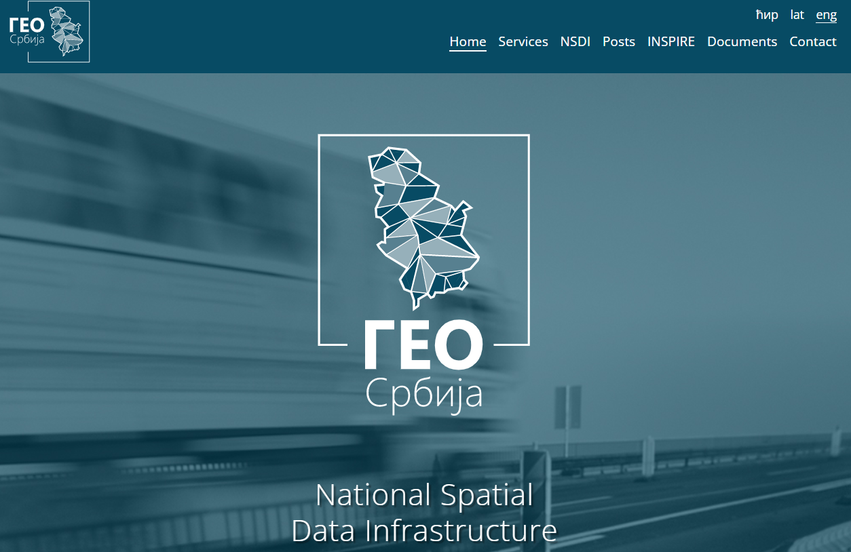
Figure 1. GEO SRBIJA portal
On the GEO SERBIA portal, it is possible to access orthophoto images with a resolution of 30cm. Then, visual identification of linear objects is performed at the municipal level (Figure 2).

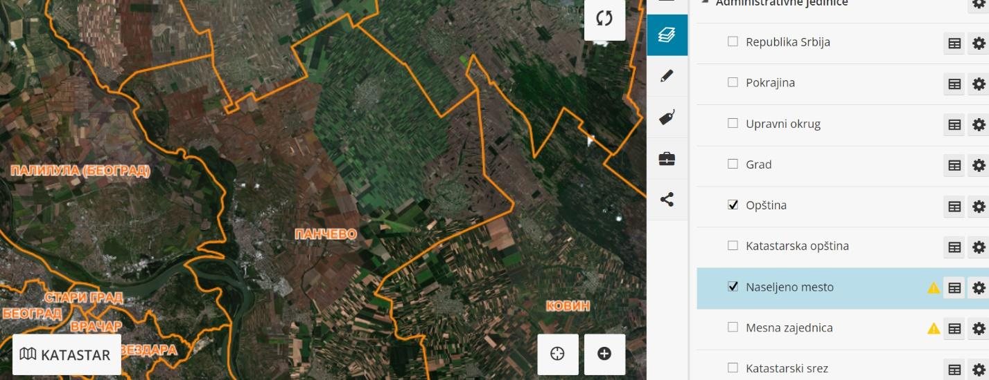
Figure 2. Display of a portal with included data on administrative units (municipalities)
Further, it is necessary to visually identify linear objects, as shown in the Figure 3.
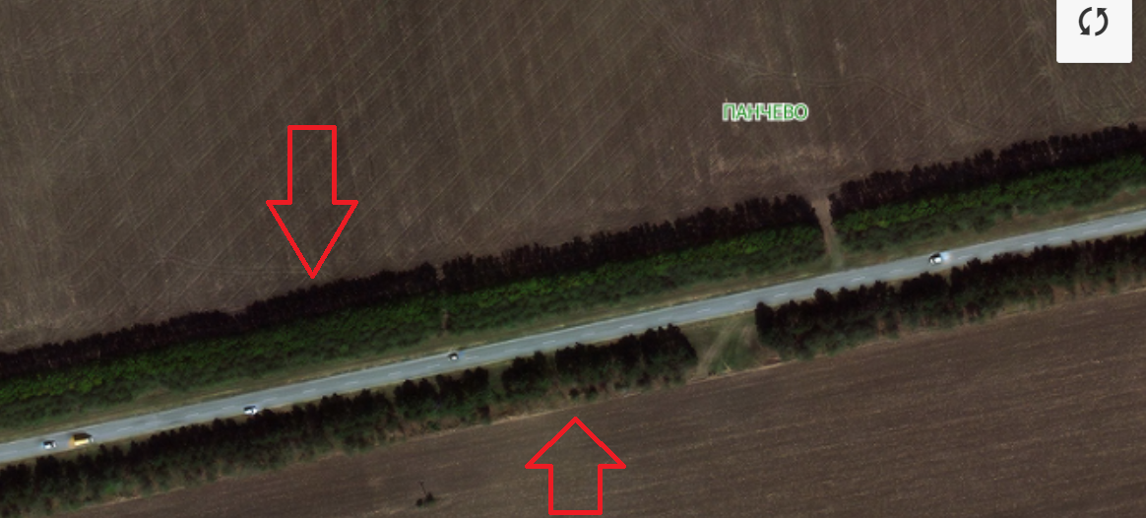
Figure 3. Identified double-row forest protection belt
Further, it is necessary to label the identified objects as a linear type of object (Figure 4.).

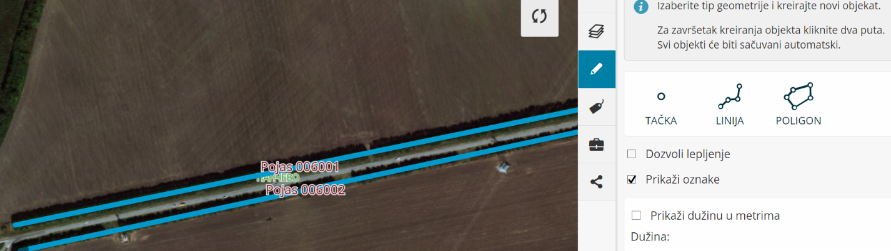
Figure 4. Protective forest belts identified as linear objects (00601 i 00602).
Finally, it is necessary for all identified belts in this way (through orthophoto images) to be exported from the portal in the appropriate extension (shapefile, csv, kml) (Figure 5.) that later allows for accessing their location (for example via Google Maps application) for planning field work on collecting data of identified (potential) AF practices.

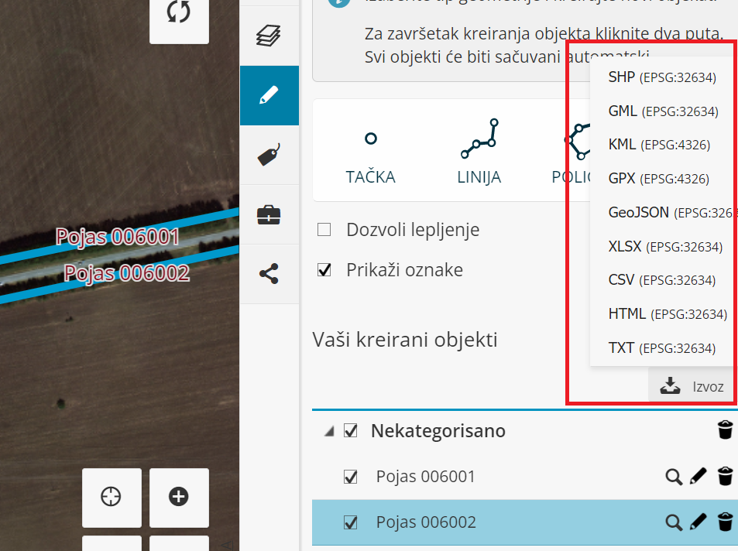
Figure 5. Exporting identified belts in the appropriate extension.

CONCLUSION
The methodology for creating a digital database is one of the project results (outputs) planned within work package 2 (WP2 Preparation). A well-defined methodology represents an important step in the process of creating a digital database that has the potential for wide range of usage in planning, design, monitoring, evaluation and research in agroforestry.
This guide is primarily intended for creating a database on the practices of agroforestry that are present in the Western Balkans region, particularly for the most common agroforestry practices in countries of AGFORWEB consortium. In order to create a digital database that includes other agroforestry systems/practices, this guide should be extended and updated.

